Day 1 : Data Analytics Fundamentals
Date:10/09/2026
- Definition of Data Analytics :
Data Analytics = Studying data to find useful information and answers.
For example, from the restaurant data, we can ask:
- Which food is ordered most?
- What is the total revenue?
- Which month has highest sales?
- Why are sales decreasing?
- What is the average rating?
The process of finding these answers is Data Analytics.

Simple example:
Data:
Pizza = ₹300
Burger = ₹200
Pizza = ₹400
Analytics:
Total Sales = ₹900
Pizza Sales = ₹700
Burger Sales = ₹200
Data Analytics = Data → Analysis → Useful information

- Definition of Data Science :
Data Science = Using data to solve problems and make predictions.
A company asks:
"What will our sales be next month?"
A Data Scientist uses Python + Statistics + Machine Learning + Data to predict the answer.
- Data Analyst vs Data Scientist:
Data Analyst = Finds answers from existing data.
Example:
"Why did sales decrease?"
The Data Analyst checks the data and finds the reason.

Data Scientist
Data Scientist = Uses data to predict the future.
Example:
"Will sales increase next month?"
The Data Scientist can build a Machine Learning model to predict it.

Easy to remember:
Analyst → Understands the past
Scientist → Predicts the future
Data Analyst | Data Scientist
Analyzes existing data | Analyzes data and builds predictive models
Answers business questions | Predicts future outcomes
Uses SQL, Excel, Power BI, Python | Uses Python, SQL, Statistics, ML
Creates dashboards/reports | Creates ML models
Focuses more on insights | Focuses more on prediction
Example: "Why did sales fall?" | Example: "Will sales fall next month?"
- Types of analytics :
Now we use the 4 types of Analytics.

1. Descriptive Analytics → What happened?
It tells us what happened in the past.
Example:
"March sales were ₹40,000."
So, we know sales decreased in March.
Descriptive = What happened?
2. Diagnostic Analytics → Why did it happen?
Now we ask why sales decreased.
After checking the data, we find:
"Orders decreased because delivery time increased."
Diagnostic = Why did it happen?

3. Predictive Analytics → What may happen in the future?
Now we want to know what will happen next.
Using previous data, we predict:
"Next month sales may be ₹45,000."
Predictive = What may happen in the future?

4. Prescriptive Analytics → What should we do?
Now we ask:
"What should the restaurant do to increase sales?"
Suggestion:
"Give discounts and reduce delivery time."
Prescriptive = What should we do?
- Data Science lifecycle:
Data Project Lifecycle = A data project is completed step-by-step.

1. Problem
First, decide what problem we want to solve.
Example:
"Why are Zomato sales decreasing?"

2. Collect Data
Collect the information needed for the problem.
Example:
Orders, sales, customers, restaurants, ratings.

3. Clean Data
Remove mistakes and fix missing data.
Example:
- Remove duplicate rows
- Handle missing values
- Correct wrong data
Clean data = Good data

4. Understand Data
Look at the data and understand it.
For example:
- How many rows?
- How many columns?
- What information is available?

5. Analyze Data
Study the data and find patterns.
Example:
Which city has the highest sales?
Which restaurant has low sales?

6. Visualize Data
Show the results using charts and graphs.
Example:
- Bar chart
- Line chart
- Pie chart
- Power BI dashboard

7. Find Insights
Find something useful from the analysis.
Example:
"Pune has the highest sales."

8. Give Solution
Based on the insight, suggest what to do.
Example:
"Improve delivery time to increase customer orders."

9. Deploy
Make the dashboard/model available for actual use.
Example:
Company uses your Power BI dashboard.

10. Monitor
Keep checking the results and update the project when needed.

Real-World Examples :
- Zomato → Analyze orders, sales, ratings, delivery time
- Netflix → Recommend movies to users
- Amazon → Recommend products
- Bank → Detect fraud transactions
- Hospital → Analyze patient data
- Weather → Predict temperature/rain

Technologies Used by Data Analysts :
- Excel → Data cleaning & analysis
- SQL → Get data from database
- Python → Data analysis
- Pandas / NumPy → Data processing
- Power BI → Dashboard & visualization
- Matplotlib / Seaborn → Charts
Data Analyst = SQL + Excel + Python + Power BI

Technologies Used by Data Scientists
- Python → Programming
- SQL → Get data
- Pandas / NumPy → Data processing
- Matplotlib / Seaborn → Visualization
- Scikit-learn → Machine Learning
- TensorFlow / PyTorch → Deep Learning
- Jupyter / Google Colab → Coding & experiments
Data Scientist = Python + SQL + Statistics + Machine Learning + Deep Learning

Day 2 :Python Fundamentals
Date:11/09/2026
Completed the following Python programs:
- Calculator
- Even/Odd Number
- Positive/Negative Number
- Largest of 3 Numbers
- Student Grade Calculator
- Multiplication Table
- Factorial
- Fibonacci Series
- Count Vowels
- Reverse a String
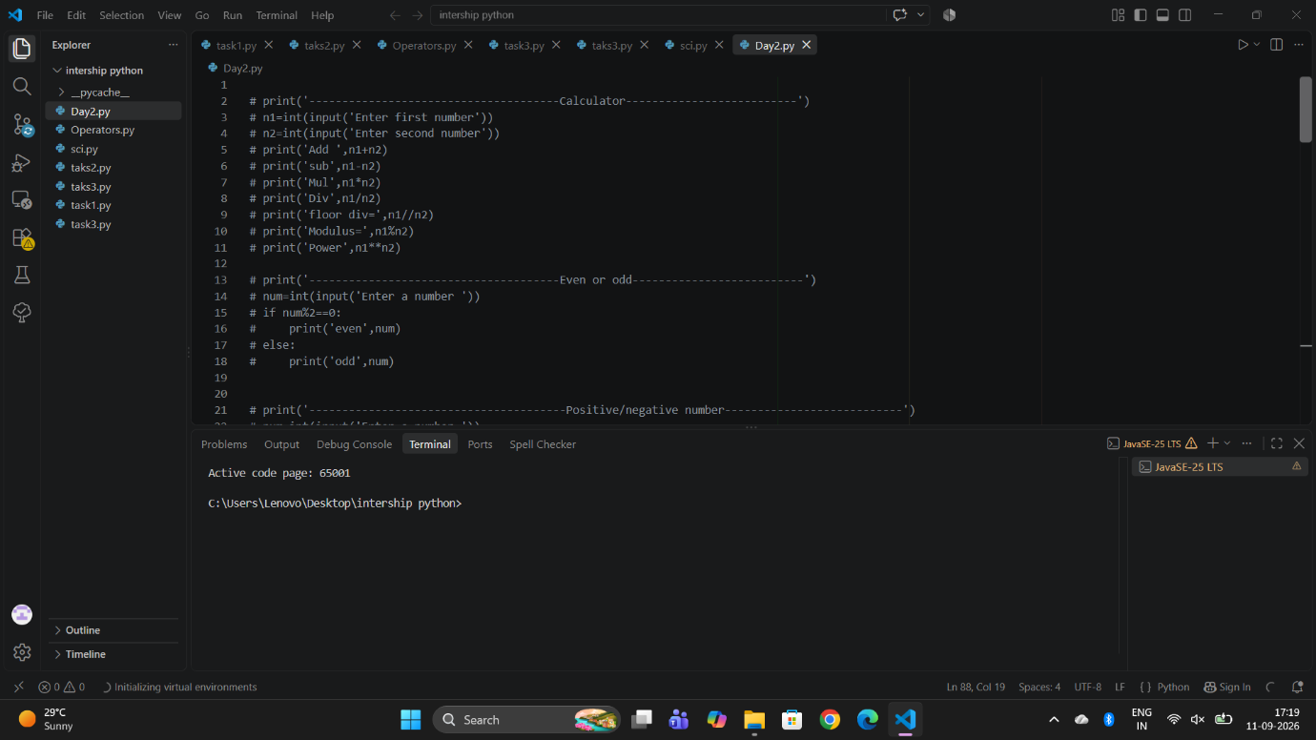
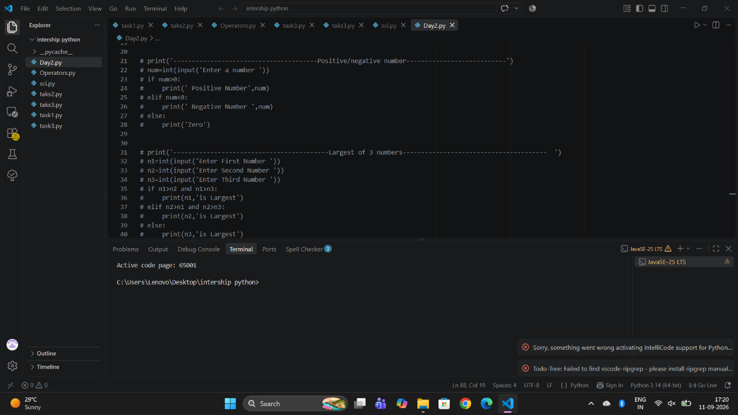

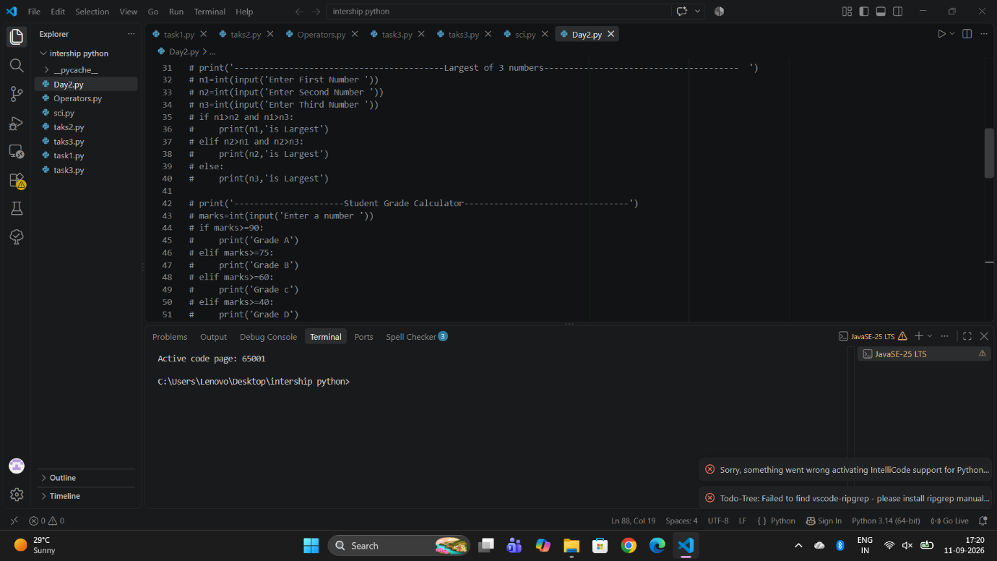
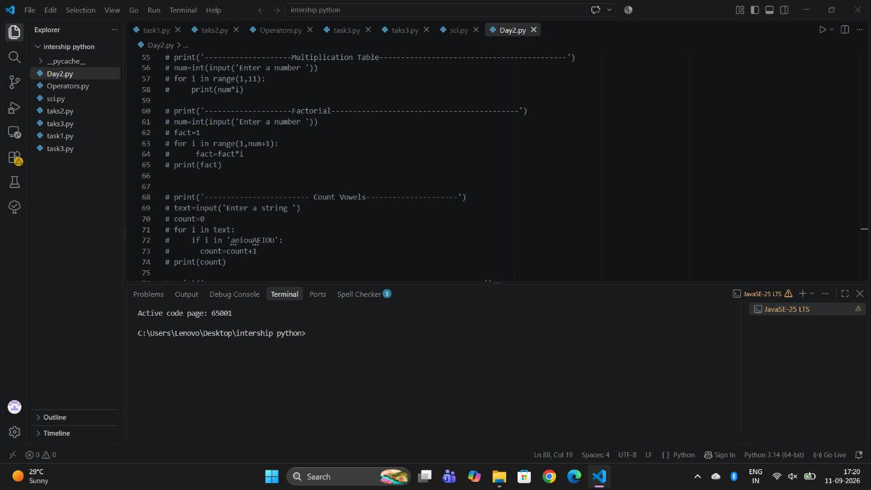
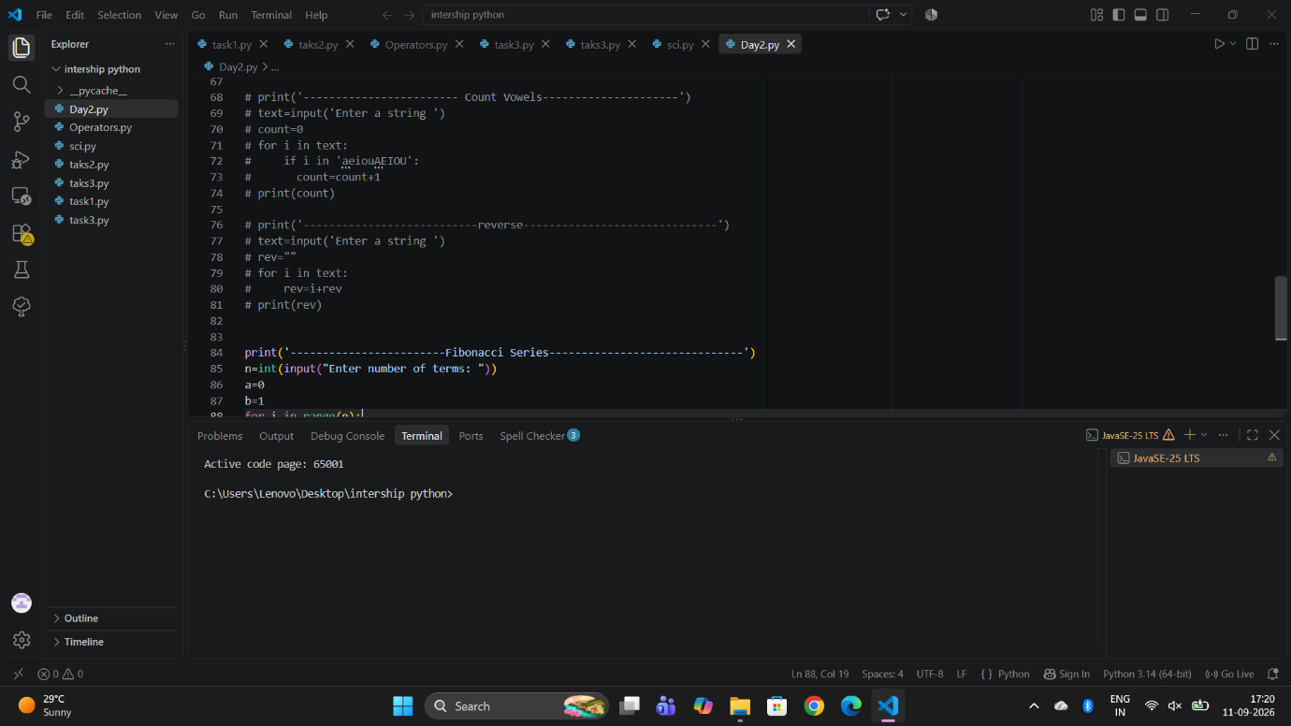
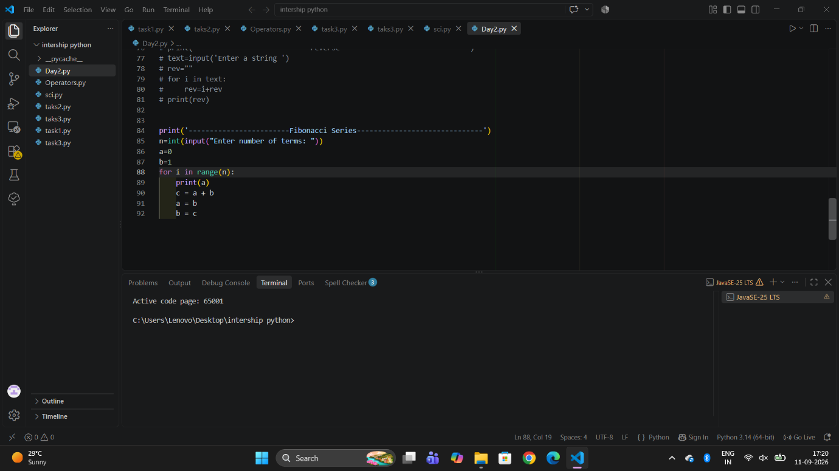

Day 3: Python Functions
Date:12/09/2026

Task Completed:
Completed the following Python programs using functions:
- calculate_average()
- calculate_max()
- calculate_min()
- calculate_grade()
- calculate_percentage()
Also created one Python program that uses all the above functions together.

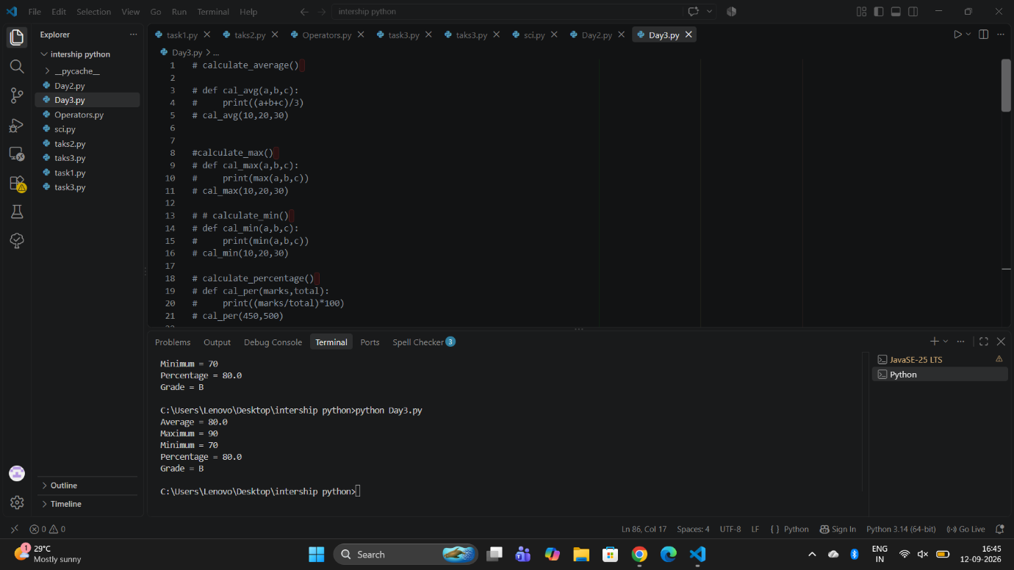
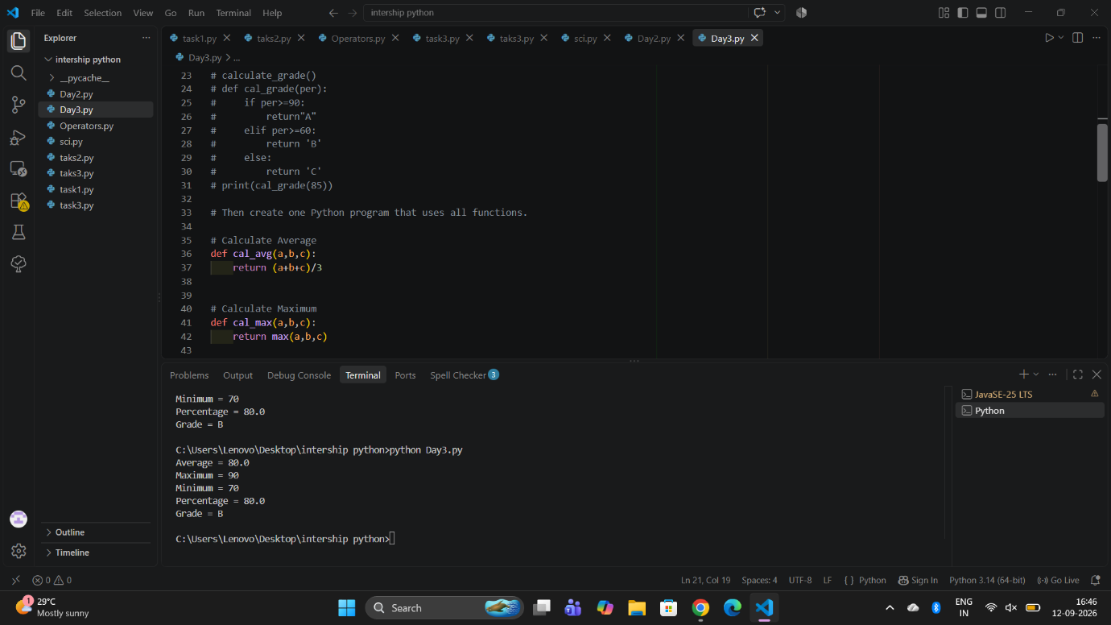
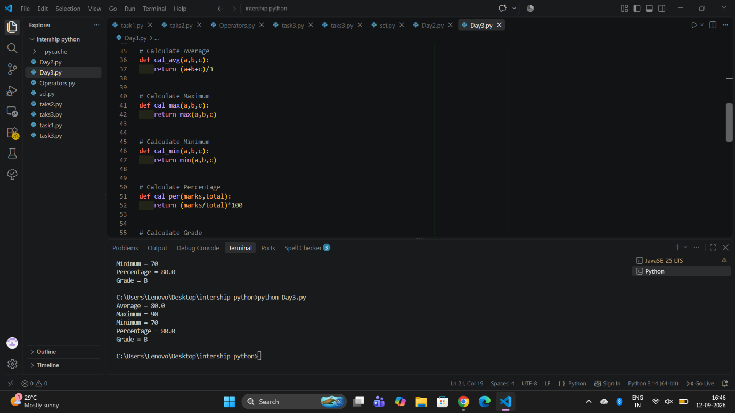
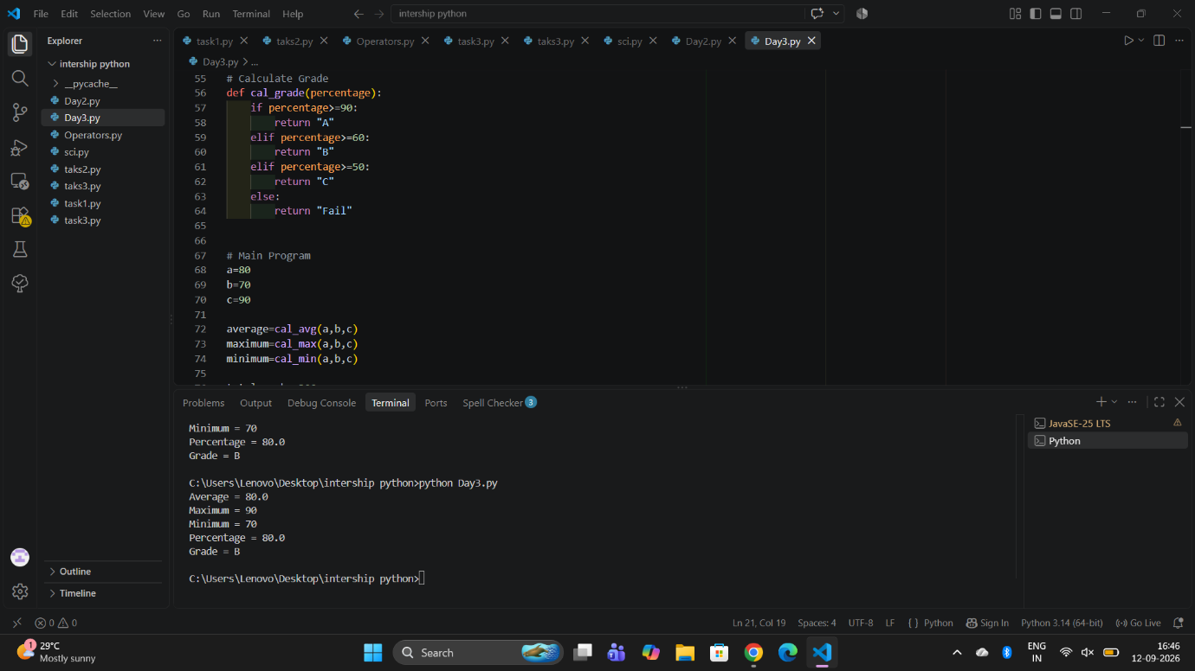
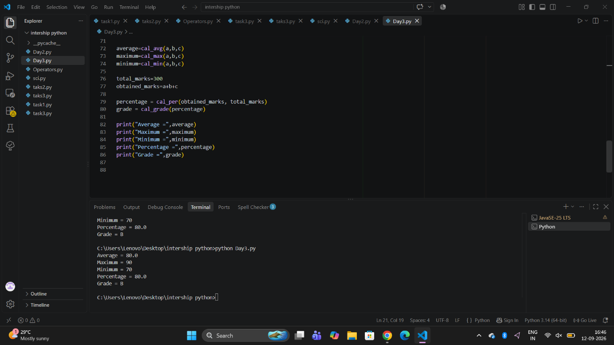

Day 4 :NumPy
Date:15/09/2026

Task Completed :NumPy
- Array: A collection of values stored together.
- Dimensions: Shows how an array is arranged.
- Shape: Shows the number of rows and columns in an array.
- Indexing: Used to access a specific value from an array.
- Slicing: Used to access a part of an array.
- Reshape: Used to change the arrangement of an array.
- Arithmetic Operations: Used to perform calculations like addition, subtraction, multiplication, and division.
- Aggregations: Used to get one result from multiple values.
- Mean: The average value of the data.
- Median: The middle value of the data.
- Standard Deviation: Shows how much the values differ or spread from the average.

Day 5 : Pandas Basics
Date:16/09/2026

Completed the following Pandas topics:
- Series
- DataFrame
- read_csv()
- head()
- tail()
- info()
- describe()
- shape
- columns
- dtypes

1. Series:

Series = one column of data.
import pandas as pd
s = pd.Series([10, 20, 30, 40])
print(s)
Output:
0 10
1 20
2 30
3 40
Think: Series = single column

2. DataFrame:
DataFrame = table with rows and columns.
data = {
"Name": ["Sneha", "Riya", "Amit"],
"Age": [22, 21, 23]
}
df = pd.DataFrame(data)
print(df)
Output:
Name Age
0 Sneha 22
1 Riya 21
2 Amit 23
Think: DataFrame = complete table

3. read_csv():
Used to read/load a CSV file into Pandas.
df = pd.read_csv("students.csv")
read_csv() = CSV file read karne ke liye

4. head():
Shows the first 5 rows.
print(df.head())
head = starting rows
You can also give a number:
print(df.head(3))
Shows first 3 rows.

5. tail():
Shows the last 5 rows.
print(df.tail())
tail = ending rows
print(df.tail(3))
Shows last 3 rows.
6. info():
Shows basic information about the DataFrame.
df.info()
It tells you:
- Number of rows
- Number of columns
- Column names
- Data types
- Missing values information
info = information about data

7. describe():
Gives statistical information about numerical columns.
print(df.describe())
It can show:
- count → number of values
- mean → average
- std → standard deviation
- min → smallest value
- max → largest value
describe = statistical summary

8. shape:
Tells you the number of rows and columns.
print(df.shape)
Output:
(100, 5)
Means:
100 rows and 5 columns
shape = (rows, columns)

9. columns:
Shows the column names.
print(df.columns)
Example output:
Index(['Name', 'Age', 'Marks'], dtype='object')
columns = column names
10. dtypes:
Shows the data type of each column.
print(df.dtypes)
Example:
Name object
Age int64
Marks int64
dtypes = data type of each column
Topic | Simple meaning
Series | One column
DataFrame | Table
read_csv() | Read CSV file
head() | First rows
tail() | Last rows
info() | Data information
describe() | Statistical summary
shape | Rows + columns
columns | Column names
dtypes | Data types
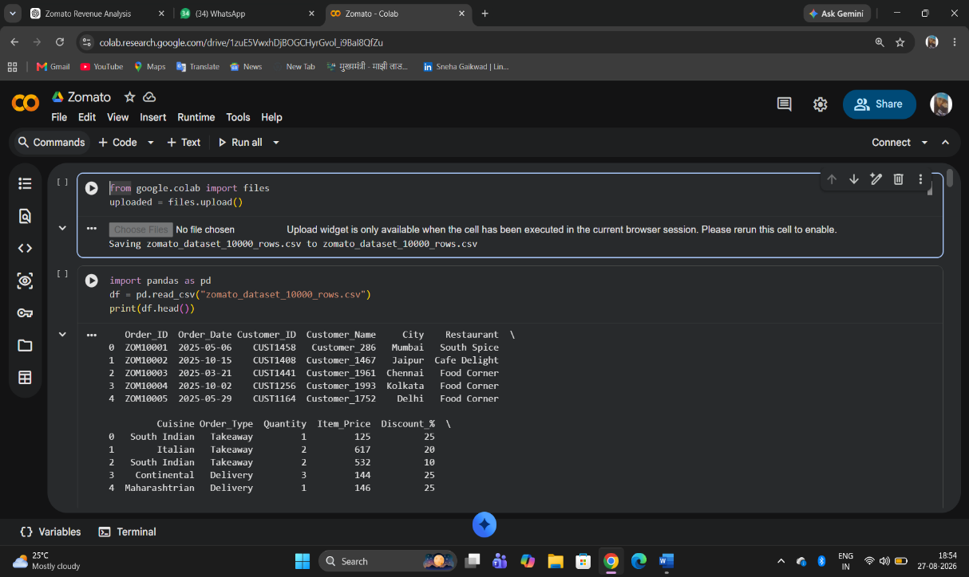
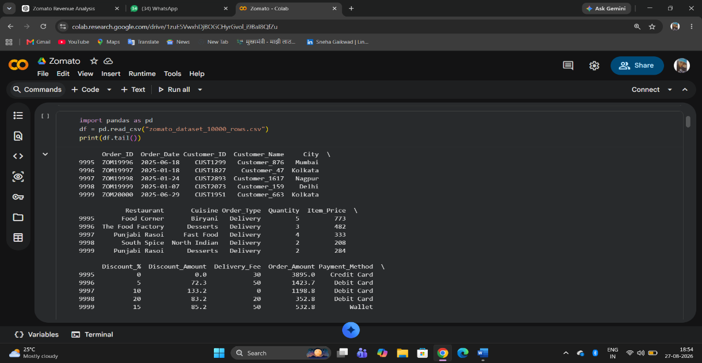

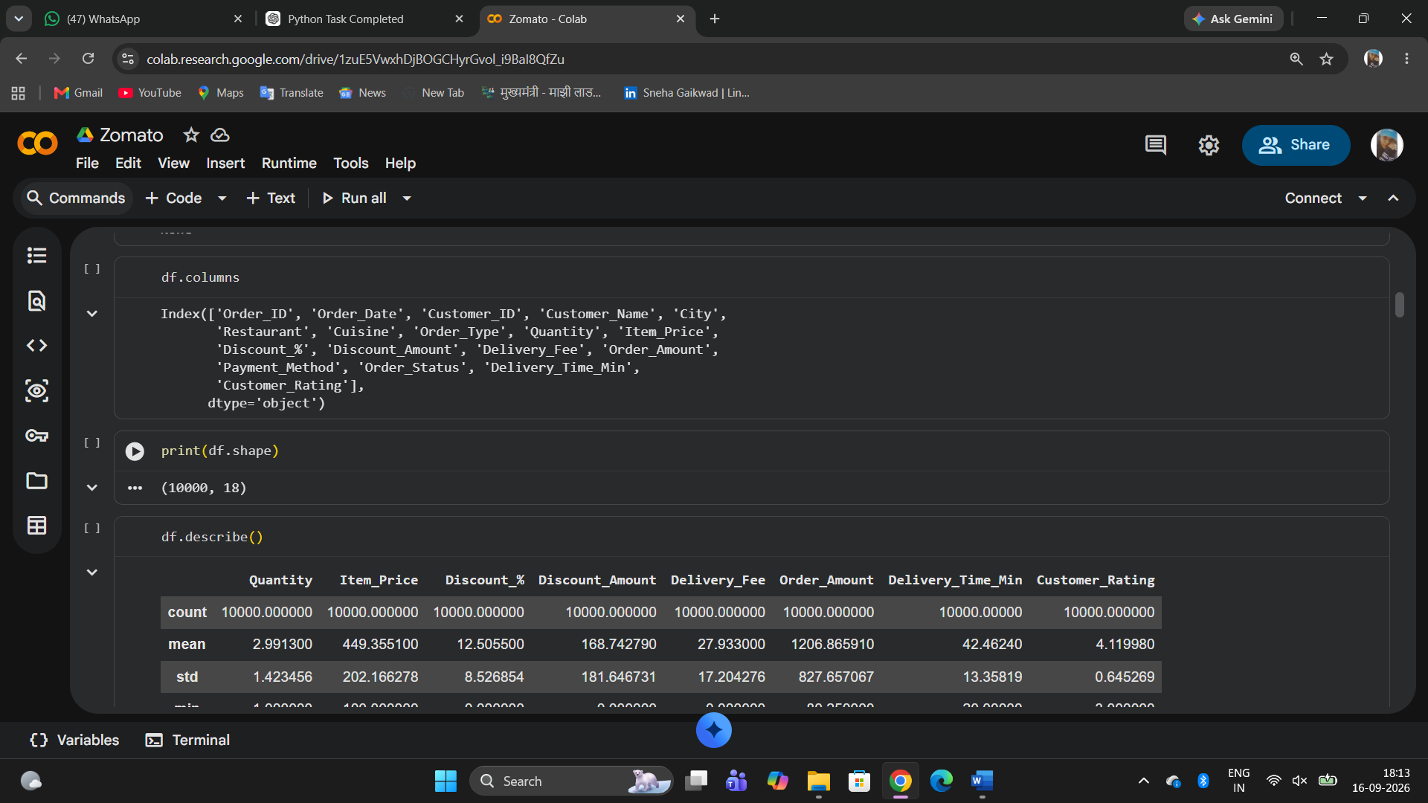
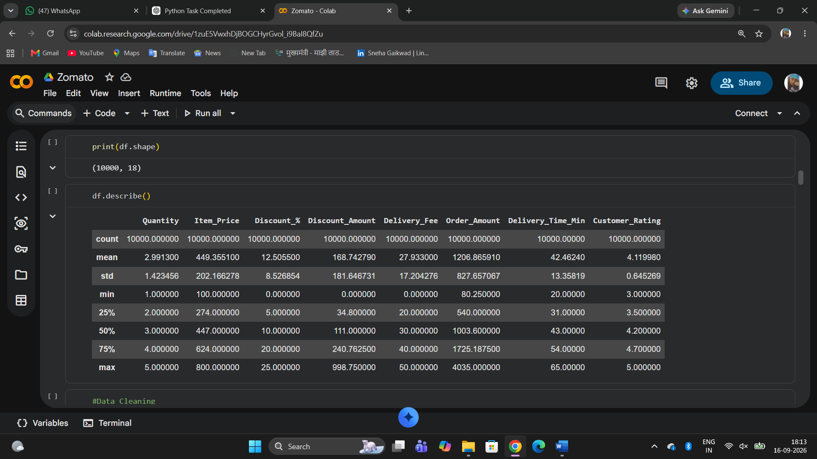

Day 6:Data Cleaning

Date:17/09/2026

Task Completed: Data Cleaning
Completed the following data-cleaning tasks on a dirty dataset:
- Identified missing values
- Counted duplicate records
- Fixed incorrect data types
- Standardized text values
- Removed/handled duplicate records
- Handled missing values
- Identified abnormal/outlier values
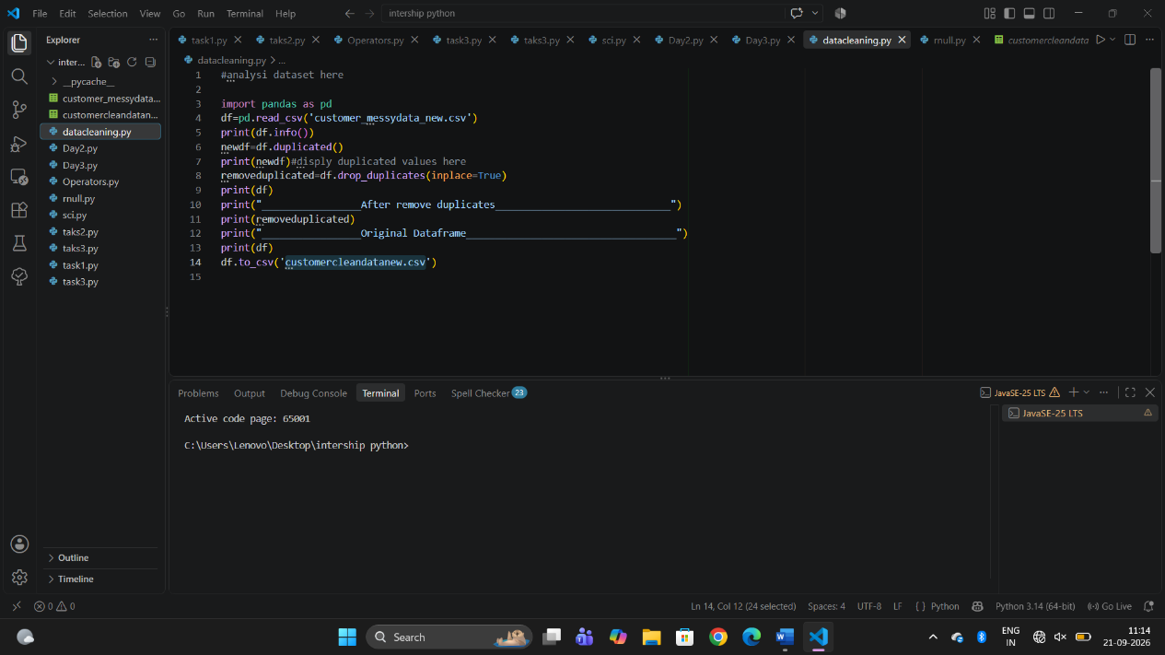

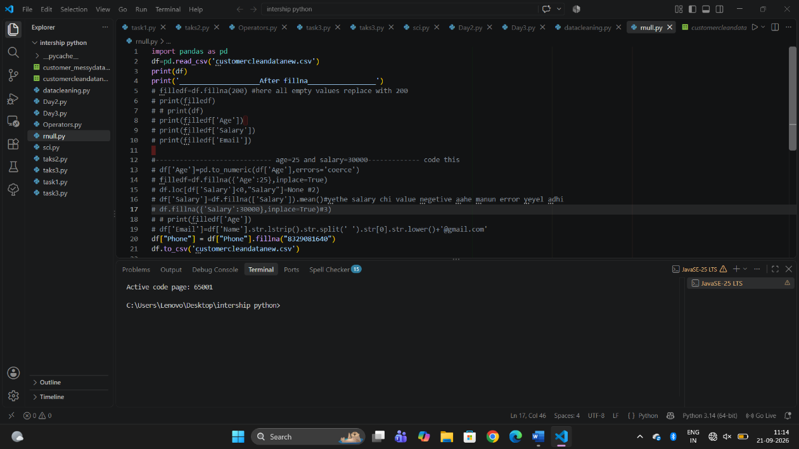

Day 7: SQL Fundamentals

Date:18/09/2026

Task Completed: SQL Database and Queries
Created a database with the following tables:
- Customers
- Products
- Orders
Completed tasks:
- Retrieved all customers.
- Found customers from Pune.
- Retrieved orders above ₹5,000.
- Identified top-selling products.
- Calculated total sales.
- Calculated average order value (AOV).
- Wrote at least 20 SQL queries to practice data retrieval, filtering, sorting, aggregation, and analysis.
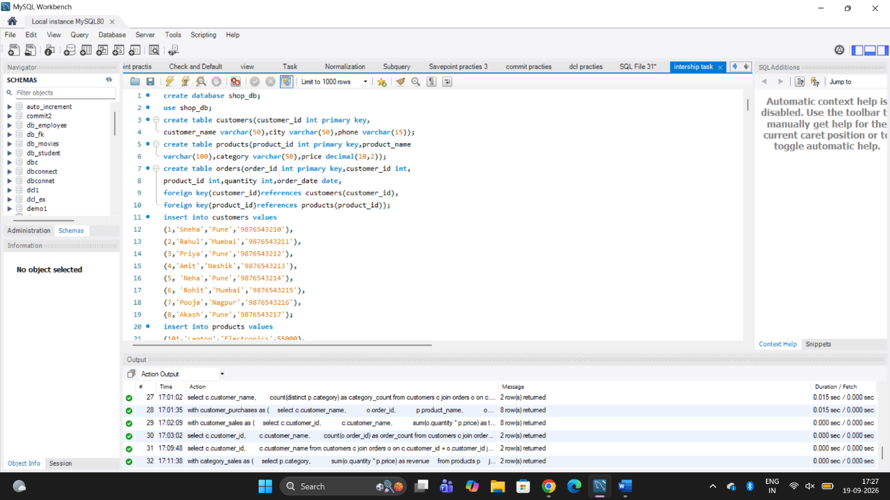

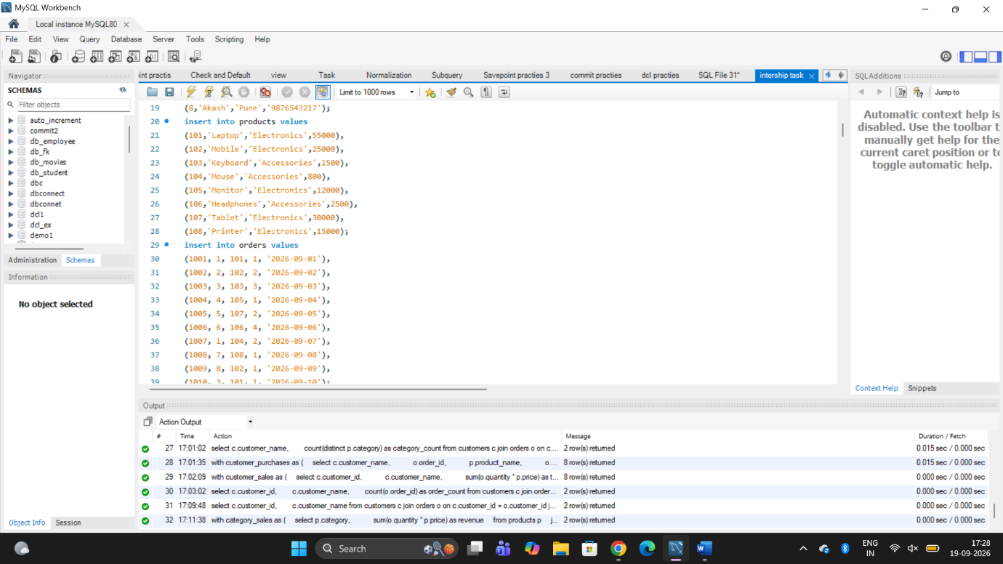
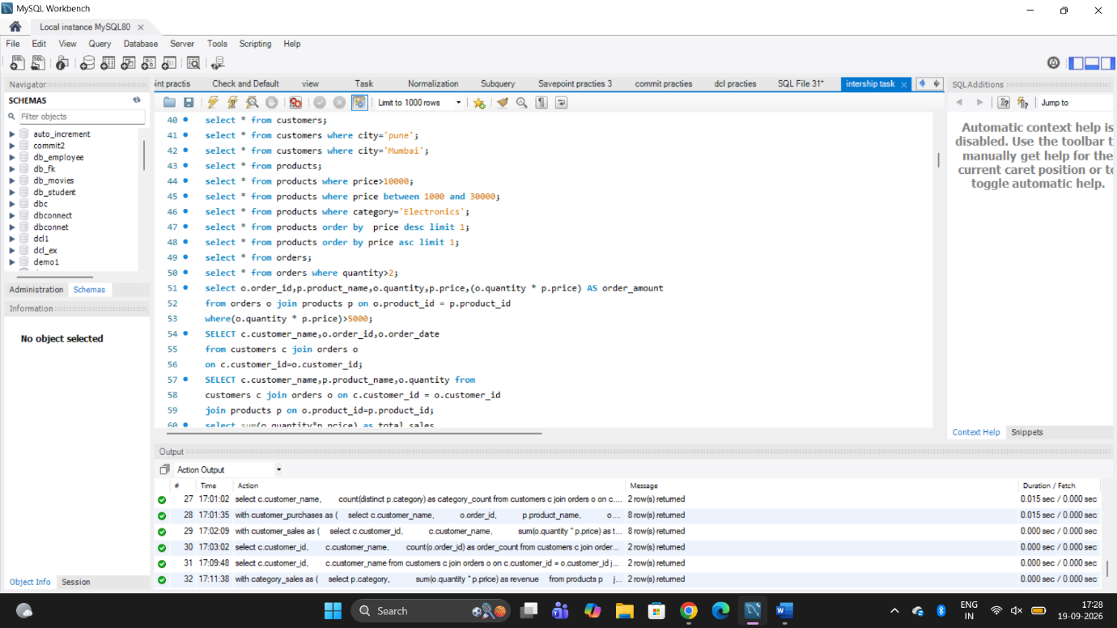

Day 8: Advanced SQL

Date:19/09/2026

Task Completed: Advanced SQL Queries
Completed topics:
- Found the top 3 customers.
- Found the top 3 products in each category.
- Ranked customers based on their purchases.
- Calculated monthly revenue.
- Retrieved previous month's revenue using window functions.
- Calculated month-over-month revenue growth.
- Ranked employees based on their salaries.
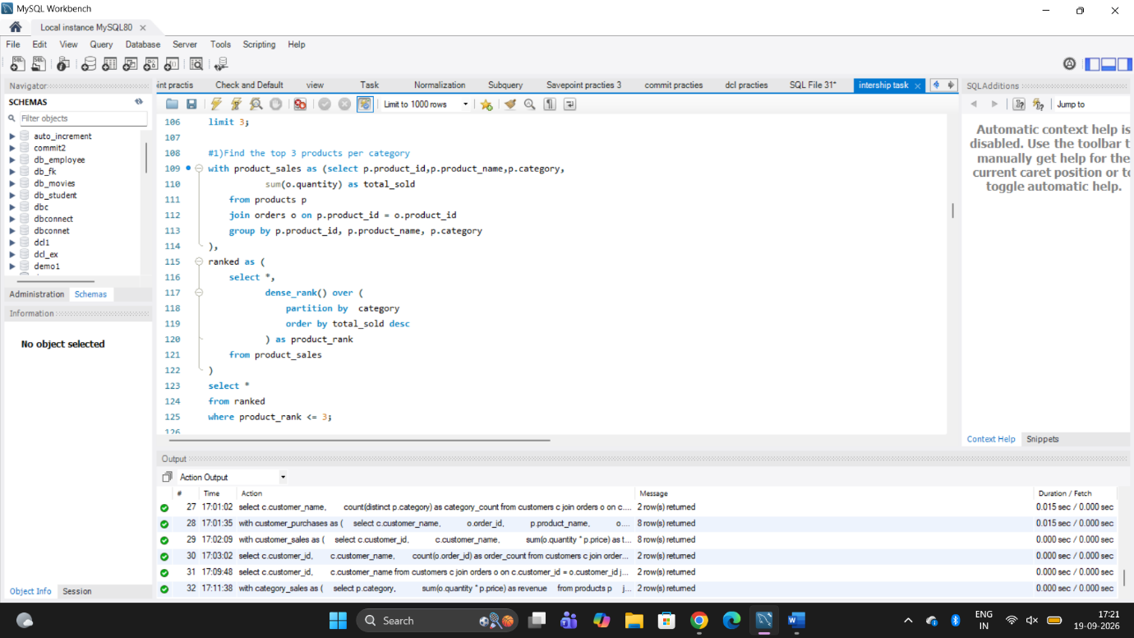

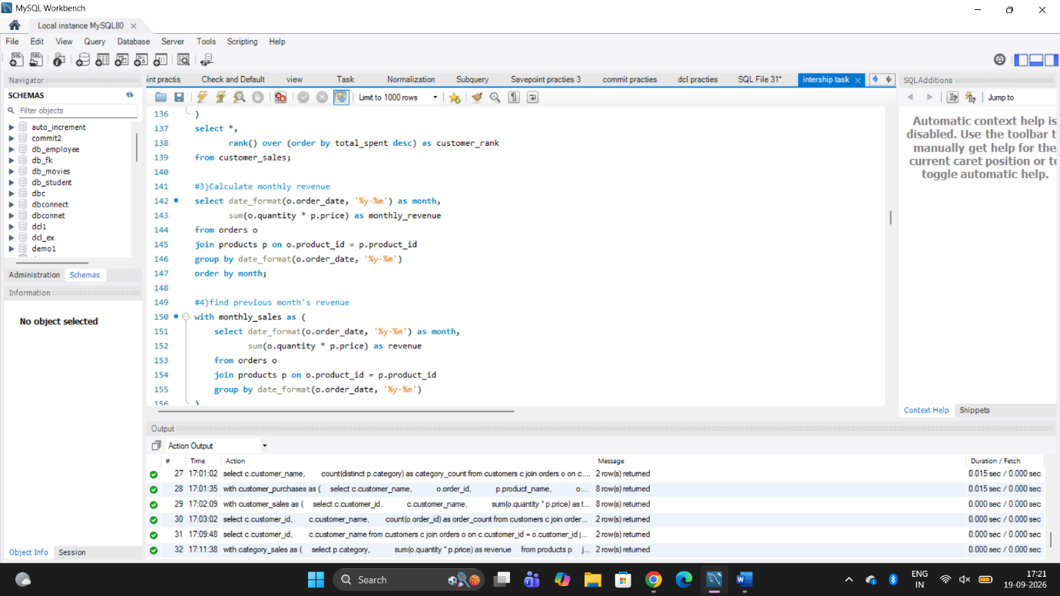
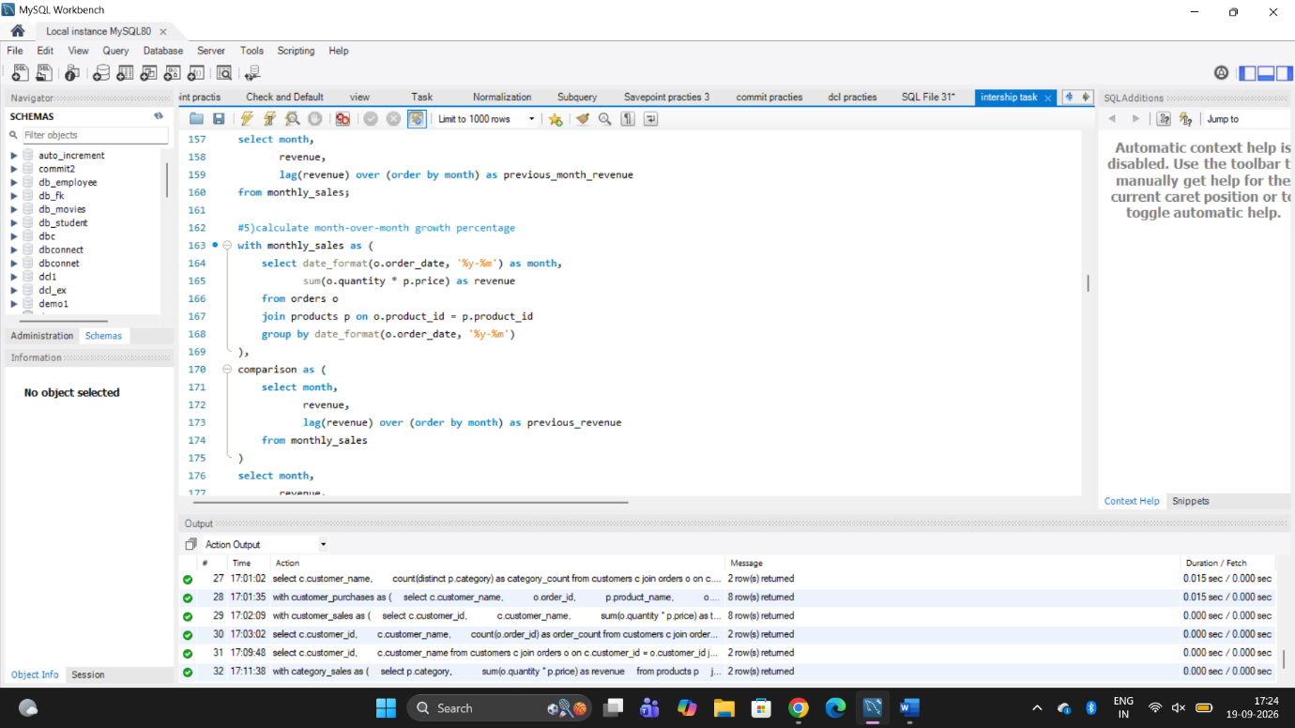

Day: 9 Statistics
Date:21-09-2026
1. Mean:Mean is the average value of a numerical column.
Formula: Mean = Sum of all values ÷ Number of values
In our dataset:We calculated the average age of all employees
Python function: df["Age"].mean()
Note: Mean can be affected by very high or very low values (outliers).
2.Median:Median is the middle value of a numerical column after arranging values in order.
In our dataset:We calculated the middle age of all employees.
Python function: df["Age"].median()
Note: Median is less affected by very high or very low values (outliers)
3. Mode: Mode is the most frequently occurring value in a numerical column.
In our dataset:We calculated the age that occurs most frequently among employees.
Python function: df["Age"].mode()[0]
Note: A dataset can have more than one mode.
4. Rang: Range is the difference between the maximum and minimum values in a numerical column.
In our dataset:We calculated the difference between the highest and lowest employee age.
Python function: df["Age"].max() - df["Age"].min()
Note: A larger range means the values are more spread out.
5. Variance: Variance measures how far the values are spread from the mean.
In our dataset:We calculated how much employee ages vary from the average age.
Python function: df["Age"].var()
Note: Higher variance means the data is more spread out.
6. Standard Deviation: Standard deviation measures the amount of variation or spread in the data.
In our dataset:We calculated how much employee ages typically vary from the average age.
Python function: df["Age"].std()
Note: Lower standard deviation means values are closer to the mean.
7. Percentile: Percentile tells us the value below which a certain percentage of data falls.
In our dataset:We calculated the 75th percentile of employee salaries.
Python function: df["Salary"].quantile(0.75)
Note: The 75th percentile means approximately 75% of the values are at or below that value.
8. Quartile: Quartiles divide the data into four equal parts.
In our dataset:We calculated Q1 (25th percentile) and Q3 (75th percentile) of employee salaries.
Python function:
df["Salary"].quantile(0.25)
df["Salary"].quantile(0.75)
Note: Q1 represents 25% of the data, while Q3 represents 75% of the data.
9. IQR (Interquartile Range): IQR is the difference between Q3 and Q1.
Formula:IQR = Q3 - Q1
In our dataset:We calculated the spread of the middle 50% of employee salaries.
Python function: q3_salary - q1_salary
Note: IQR is useful for understanding the middle spread of data and identifying outliers.
10. Correlation: Correlation measures the relationship between two numerical variables.
In our dataset:We checked the relationship between employee age and salary.
Python function: df["Age"].corr(df["Salary"])
Note: Correlation ranges from -1 to +1. A positive value means both variables tend to increase together, while a negative value means one tends to increase when the other decrease
11. Covariance: Covariance shows the direction in which two numerical variables change together.
In our dataset:
We calculated how employee age and salary change together.
Python function: df["Age"].cov(df["Salary"])
Note: Positive covariance means the variables tend to move in the same direction, while negative covariance means they tend to move in opposite directions.
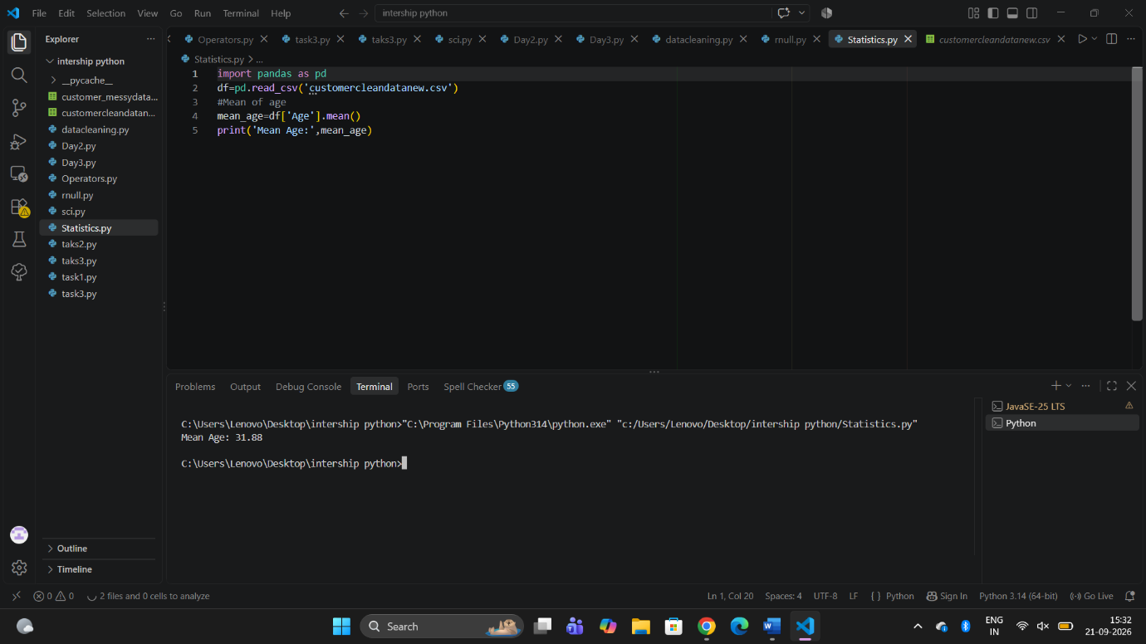
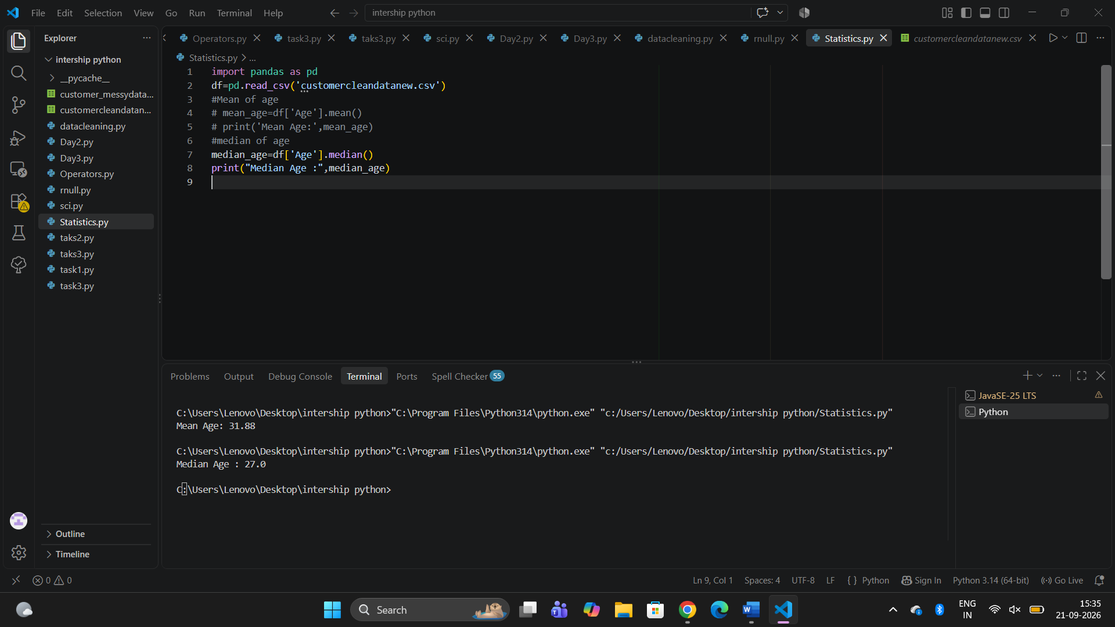
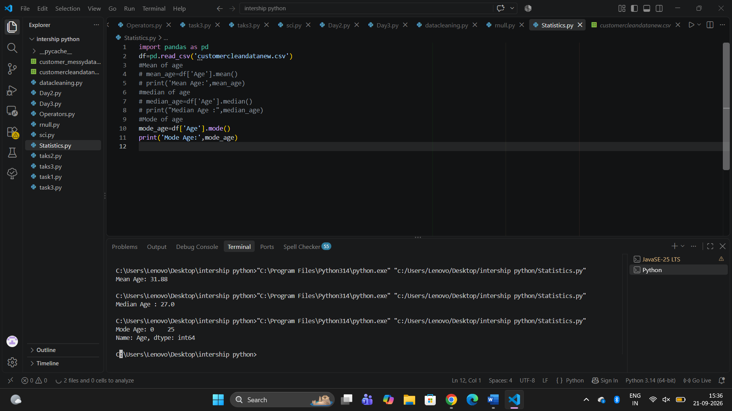
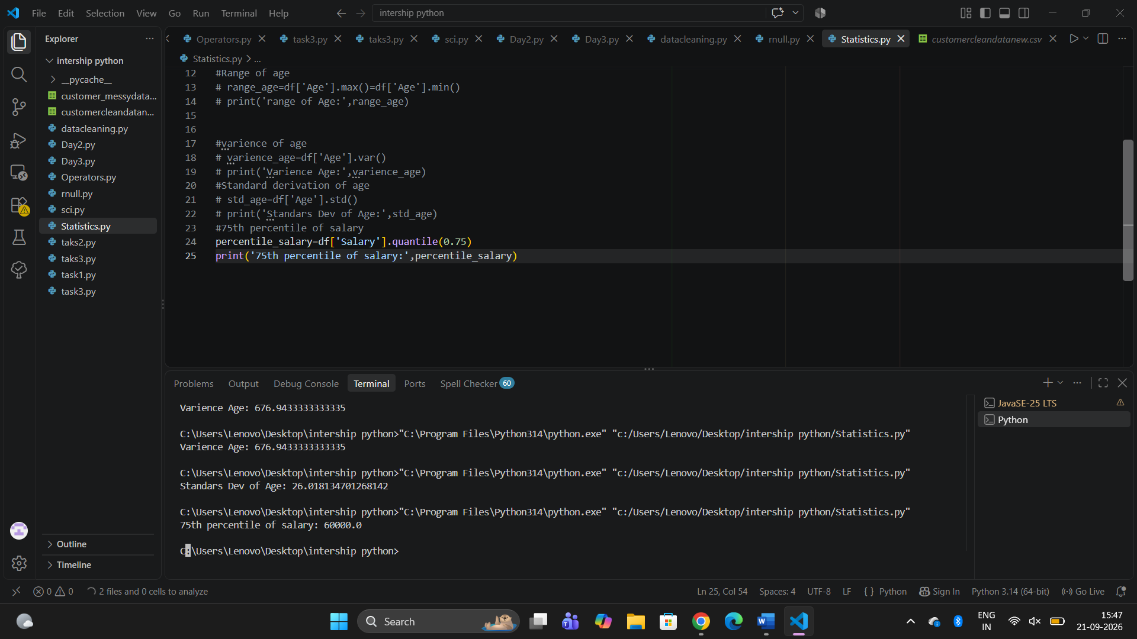

Day:10 Probability
Date:23-09-2026
Task Completed:
- Learned Probability.
- Learned Conditional Probability.
- Learned Independent and Dependent Events.
- Learned Bayes' Theorem.
- Learned Normal Distribution.
- Learned Binomial Distribution.
- Solved examples for each topic.
- Implemented probability examples using Python.

Probability — Short Definitions:
1. Probability: The chance of an event happening.
2. Conditional Probability: The probability of an event when another event is already known to have happened.
3. Independent Events: Events where one event does not affect the probability of the other.
4. Dependent Events: Events where one event affects the probability of the other.
5. Bayes' Theorem: A method to update probability using new information.
6. Normal Distribution: A bell-shaped distribution where most values are near the mean.
7. Binomial Distribution: A distribution that gives the probability of a certain number of successes in a fixed number of independent trials.

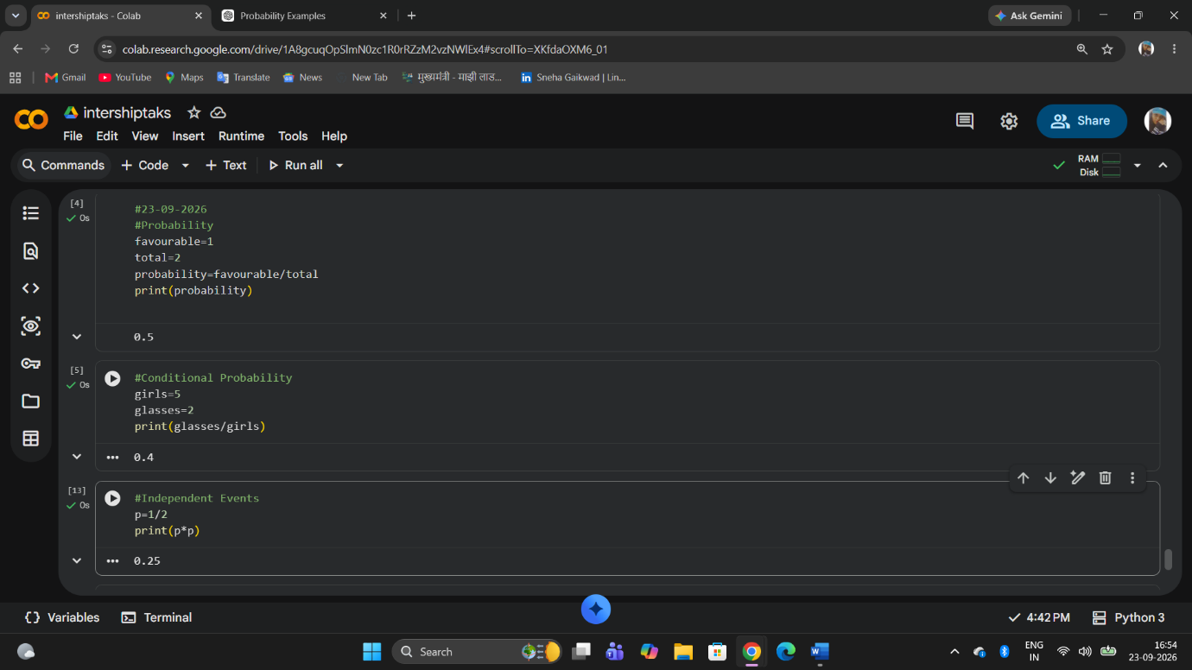
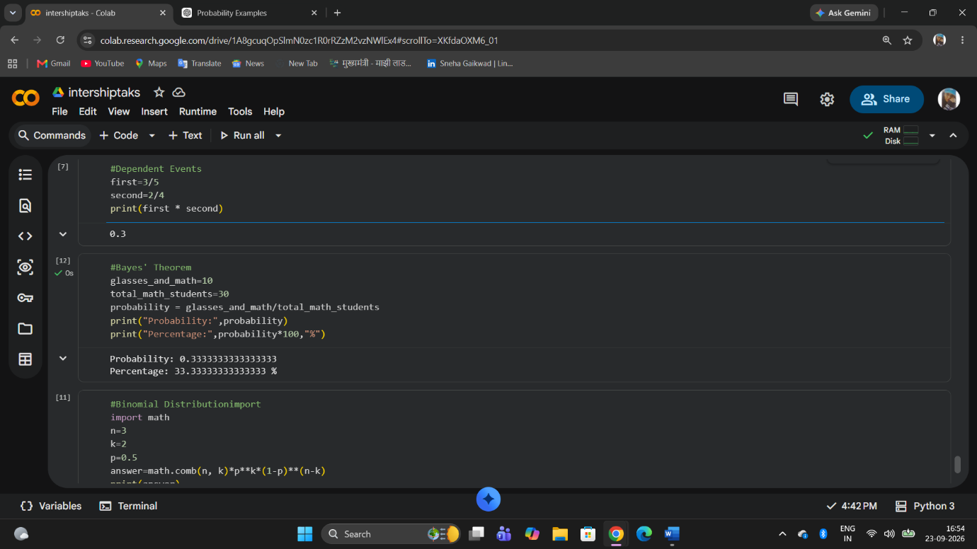

Day :11 Matplotlib
Date:24-09-2026

Task Completed :
- Learned Line Chart.
- Learned Bar Chart.
- Learned Histogram.
- Learned Scatter Plot.
- Learned Pie Chart.
- Learned Box Plot.
- Learned Area Chart.
- Practiced creating charts using Python and Matplotlib.
- Line Chart: Shows changes or trends over time.
- Bar Chart: Compares values between different categories.
- Histogram: Shows the distribution of numerical data.
- Scatter Plot: Shows the relationship between two numerical values.
- Pie Chart: Shows how each category contributes to the whole.
- Box Plot: Shows data spread and helps identify outliers.
- Area Chart: Shows trends over time using a filled area below the line.

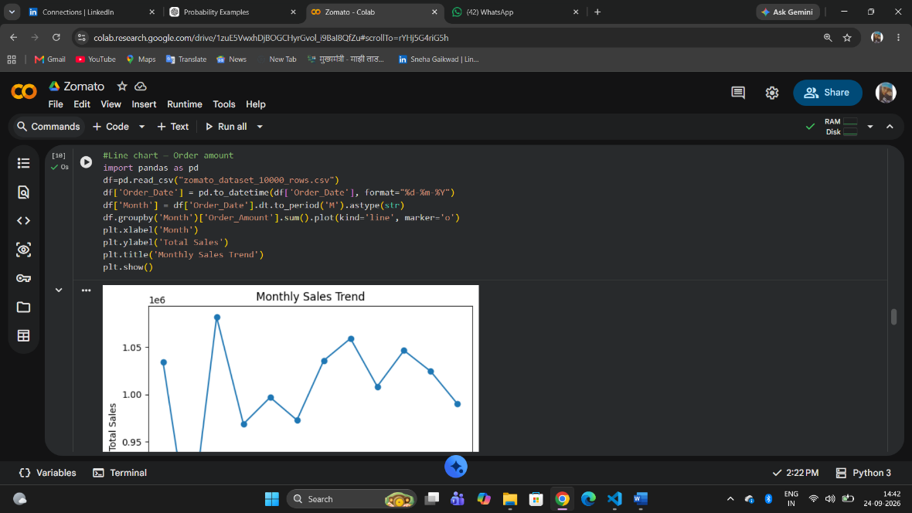
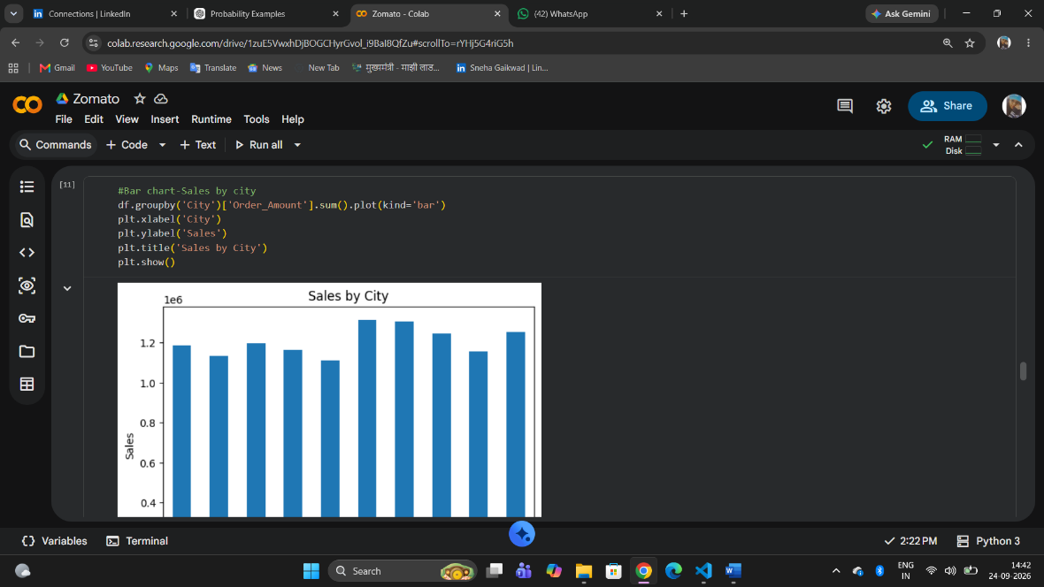

Day :12 Seaborn + Advanced EDA
Date:24-09-2026

Task Completed
- Learned Countplot.
- Learned Boxplot.
- Learned Violin Plot.
- Learned Heatmap.
- Learned Pairplot.
- Learned Distribution Plots.
- Practiced creating visualizations using Seaborn.
- Performed Exploratory Data Analysis (EDA).
- Countplot: Shows the number of observations in each category.
- Boxplot: Shows data spread, median, and possible outliers.
- Violin Plot: Shows data distribution and density.
- Heatmap: Uses colors to represent values in a table or matrix.
- Pairplot: Shows relationships between pairs of numerical variables.
- Distribution Plot: Shows how numerical data is spread or distributed.

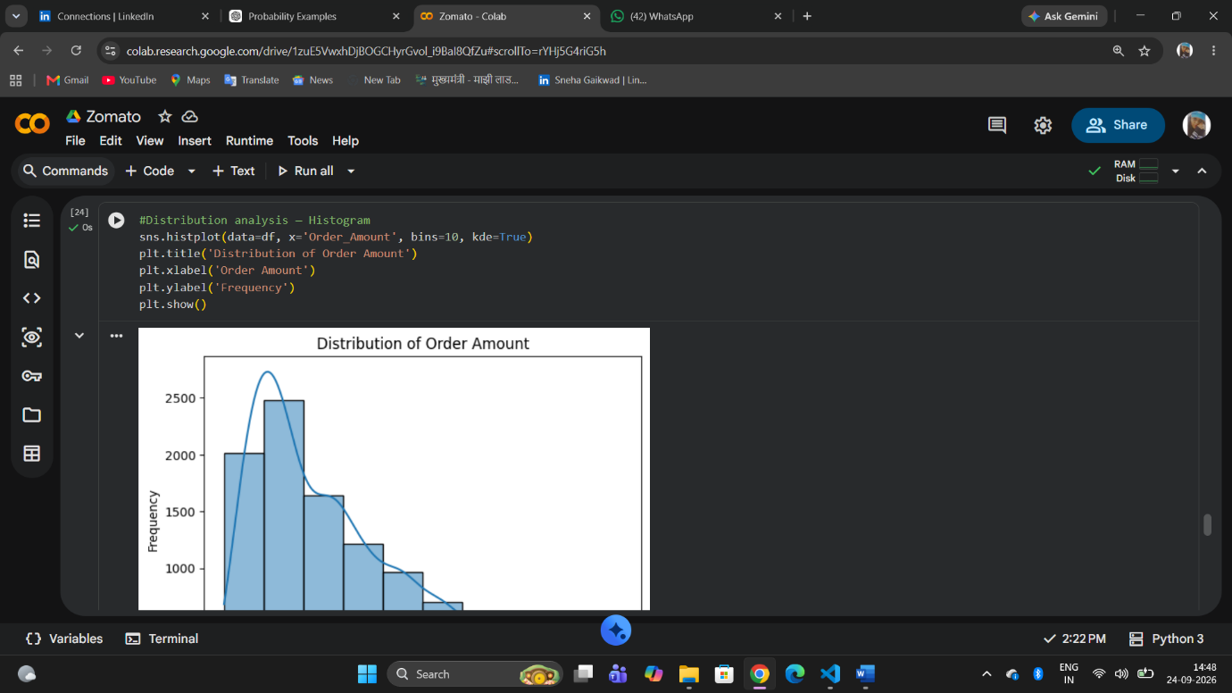
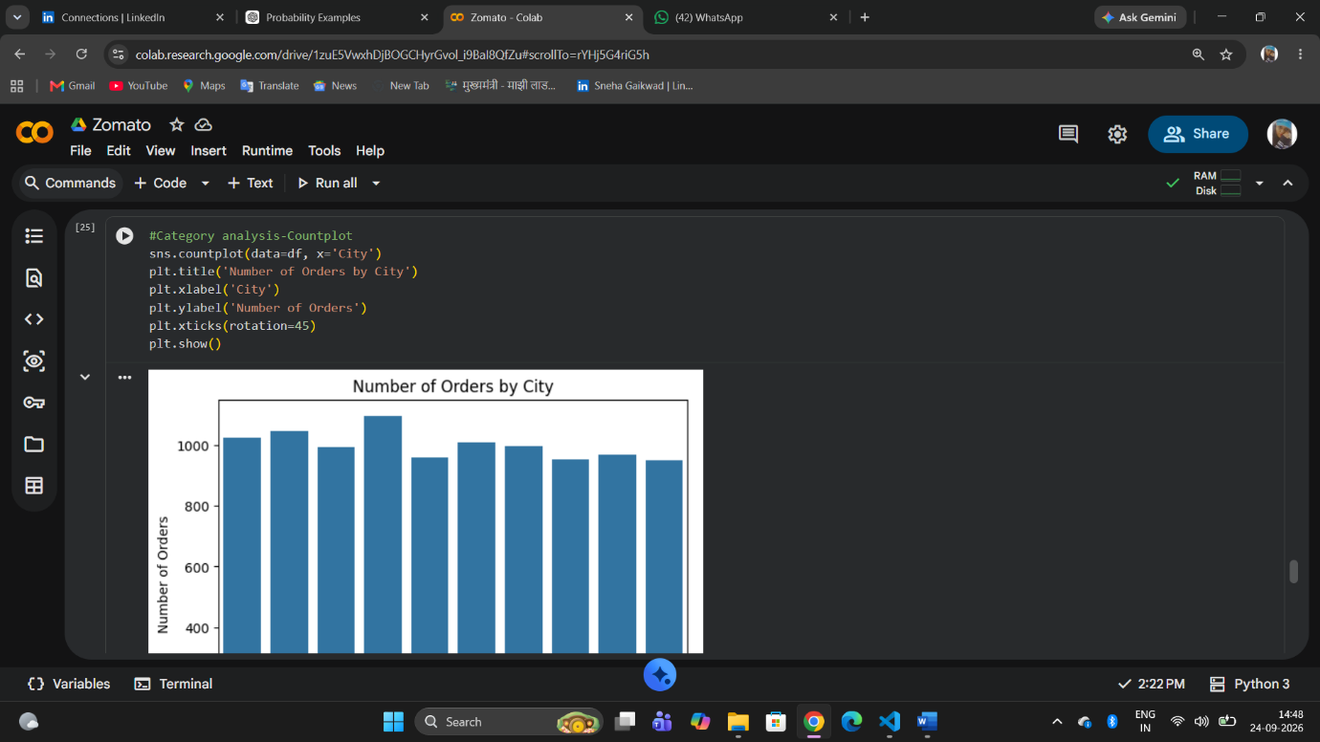

Day:13 Power BI
Date:25-09-2026

Task Completed:
Learned :
- Import Data – Import data into Power BI.
- Power Query – Clean and prepare data.
- Transform Data – Filter, replace, split, and modify data.
- Data Types – Set text, number, date, decimal, etc.
- Filters – Filter the required data.
- Slicers – Create interactive filters for dashboards.
- Charts – Create visualizations such as bar, line, pie, etc.
- Cards – Display important KPIs and numbers.
- Tables – Display detailed data in rows and columns.
- Matrix – Display summarized data in a report-style format.

One-Page Sales Dashboard:
Created a one-page Sales Dashboard in Power BI with:
- Total Sales
- Total Orders
- Total Customers
- Sales by Category
- Sales by Region
- Monthly Sales

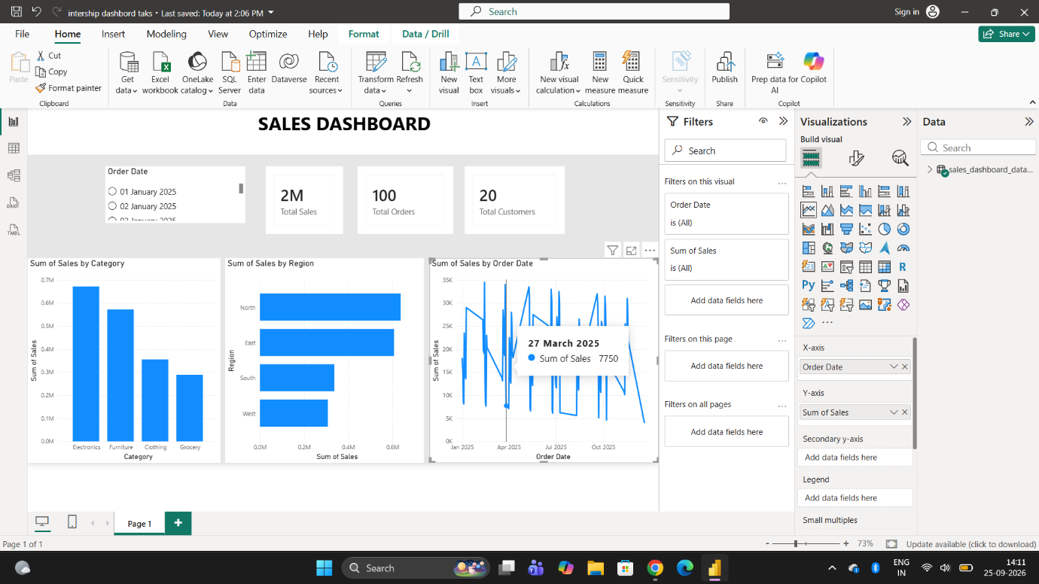

Day:14 DAX
Date:25-09-2026
Task Completed:

Learned: Important DAX Functions:
- CALCULATE – Changes the filter context and calculates an expression.
- FILTER – Filters a table based on a condition.
- ALL – Removes filters from a table or column.
- SUMX – Calculates a value row by row and then adds the results.
- COUNTROWS – Counts the number of rows in a table.
- DISTINCTCOUNT – Counts unique values in a column.
Created the following 6 Power BI measures:
- Total Revenue
- Total Profit
- Total Orders
- Total Customers
- Average Order Value (AOV)
- Profit Margin
